

Tribhuvan University

Faculty of Humanity and social science

**Lab Report**

**Of Networking Programming**

**Submitted to:**

Department of Computer Application

Jana Bhawana Campus

***In partial fulfillment of the requirement for the Bachelor in computer Application***

Submitted by: Submitted to: Kritisa Adhikari Suman Mali

JANA BHAWANA CAMPUS

GODAWARI-11, LALITPUR

Network Programming

Practical File Record

Name: Kritisa Adhikari Roll No: 04

|  |  |  |  |
| --- | --- | --- | --- |
| S.N. | Name of Practical | Date | Signature |
| 1. | Write a program that gets the localhost IP address, canonical name using InetAddress methods. |  |  |
| 2. |  |  |  |
|  |  |  |  |
|  |  |  |  |
|  |  |  |  |
|  |  |  |  |
|  |  |  |  |
|  |  |  |  |
|  |  |  |  |

**OUTPUT**

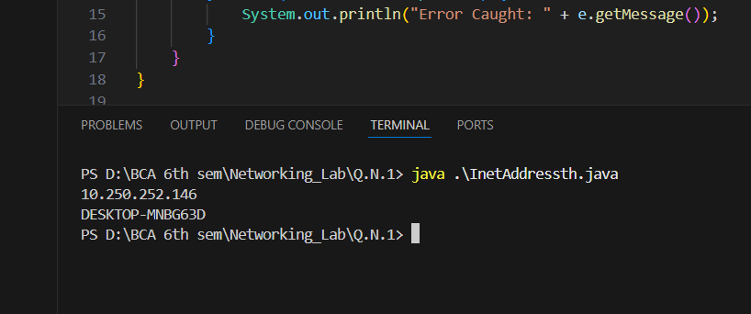

**OUTPUT**